Shunt Peaking:

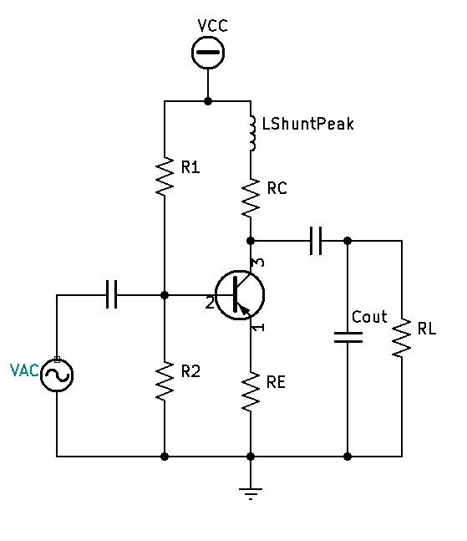

* Calculate and or Measure your existing $fch$.
* Determine your actual $Cout$ based off measured $fch$.
* Design Shunt Peaking of optimal flatness using an Improvement Factor of $k=1.414$
  + Calculate $newfch$:
 $newfch=oldfch×k$

 $newfch=oldfch×1.414 (optimal flatness)$

+ Calculate L:
    - Make $fr=.707(newfch)$

$fr=\frac{1}{2π\sqrt{LC}}$

$.707(newfch)=\frac{1}{2π\sqrt{LC_{out}}}$

$\sqrt{LC_{out}}=\frac{1}{2π(.707newfch)}$

$LC_{out}={(\frac{1}{2π\left(.707newfch\right)})}^{2}$

$L=\frac{{(\frac{1}{2π\left(.707newfch\right)})}^{2}}{C_{out}}$

$L={{C_{out}}^{-1}(\frac{1}{2π\left(.707newfch\right)})}^{2}$